**Bug Report**

**Bug ID: 001**

**Bug Summary:** Login page: Authorization without entering datas

**Environment/URL:** <https://qwallity-exam.herokuapp.com/>

**OS/Browser:** Windows 10, 64-bit / Google Chrome

**Submit date:** 18.05.2022

**Version:** 1

**Reporter:** Anzhela Khachatryan

**Steps to reproduce:**

1. Open application
2. No fill any data in username and password fields
3. Click Login button

**Actual Result:** Redirect to non-admin user page

**Expected Result:** System massage: “Fill entering critendiles”

**Screenshots/Videos:**

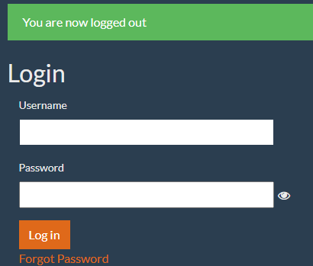

**Severity:** Critical

**Priority:** High

**Status:** Open

**Bug ID: 002**

**Bug Summary:** Login page: Forgot password link: Internal Server Error

**Environment/URL:** <https://qwallity-exam.herokuapp.com/>

**OS/Browser:** Windows 10, 64-bit / Google Chrome

**Submit date:** 18.05.2022

**Version:** 1

**Reporter:** Anzhela Khachatryan

**Steps to reproduce:**

1. Open Login page
2. Fill username field
3. Click Forgot password Link
4. Fill registered email address in email field

**Actual Result:** Internal Server Error

**Expected Result:** Get email with code

**Screenshots/Videos:**

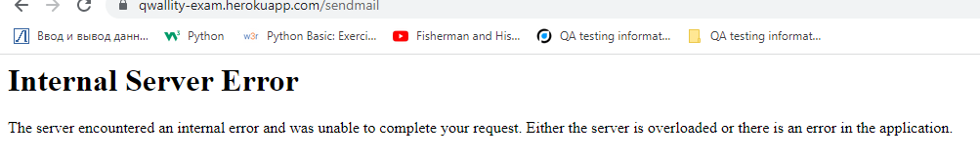

**Severity:** High

**Priority:** High

**Status:** Open

**Bug ID: 003**

**Bug Summary:** Pasting the internal URL into the address bar of the browser without authorization

**Environment/URL:** <https://qwallity-exam.herokuapp.com/>

**OS/Browser:** Windows 10, 64-bit / Google Chrome

**Submit date:** 18.05.2022

**Version:** 1

**Reporter:** Anzhela Khachatryan

**Steps to reproduce:**

1. Open app without authorization
2. Open app in new browser tab and log in like admin user
3. Copy part of URL from admin user profile (ex. add course)
4. Paste copied part of url into the address bar of unauthorized url

**Actual Result:** Open admin user profile

**Expected Result:** Inner page should not open

**Screenshots/Videos:**

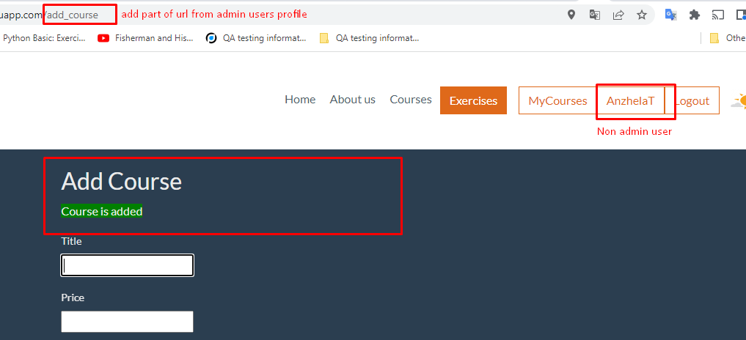

**Severity:** Critical

**Priority:** High

**Status:** Open

**Bug ID: 004**

**Bug Summary:** Fields in Change discount page accepted letters, symbols

**Environment/URL:** <https://qwallity-exam.herokuapp.com/>

**OS/Browser:** Windows 10, 64-bit / Google Chrome

**Submit date:** 18.05.2022

**Version:** 1

**Reporter:** Anzhela Khachatryan

**Steps to reproduce:**

1. Open “Change discount” page
2. Choose course type from drop down list
3. Fill letters or symbols in discount field
4. Fill letters or symbols in course_count field
5. Click “Change discount” button

**Actual Result:** System message: “Discount is changed”

**Expected Result:** System message: “Fields accepting only numbers”

**Screenshots/Videos:**

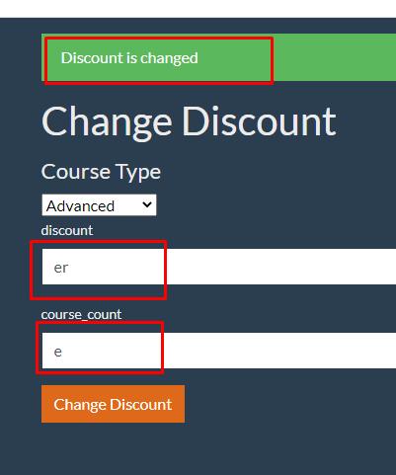

**Severity:** Critical

**Priority:** High

**Status:** Open

**Bug ID: 005**

**Bug Summary:** Edit course: Left alignment not working

**Environment/URL:** <https://qwallity-exam.herokuapp.com/>

**OS/Browser:** Windows 10, 64-bit / Google Chrome

**Submit date:** 18.05.2022

**Version:** 1

**Reporter:** Anzhela Khachatryan

**Steps to reproduce:**

1. Open edit course page
2. In description field click to change text alignment to the left

**Actual Result:** The left alignment button not clickable

**Expected Result:** Thh text should aligned to the left

**Screenshots/Videos:**

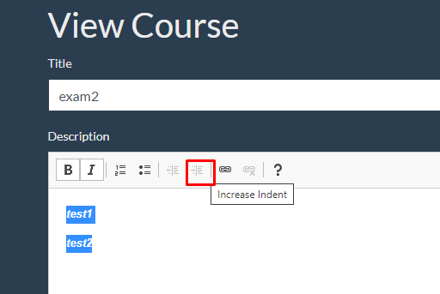

**Severity:** Low

**Priority:** Low

**Status:** Open

**Bug ID: 006**

**Bug Summary:** Edit course: after add link it isn't open when clicking

**Environment/URL:** <https://qwallity-exam.herokuapp.com/>

**OS/Browser:** Windows 10, 64-bit / Google Chrome

**Submit date:** 18.05.2022

**Version:** 1

**Reporter:** Anzhela Khachatryan

**Steps to reproduce:**

1. Open edit course page
2. In description field click to add link
3. Click added link (in description field)

**Actual Result:** The page are not redirect

**Expected Result:** Redirect by link

**Screenshots/Videos:**

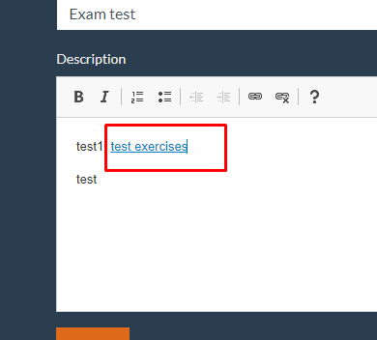

**Severity:** Low

**Priority:** Low

**Status:** Open